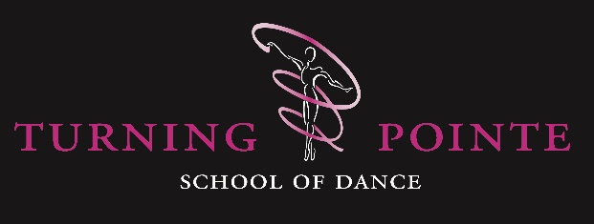

Frequently Asked Questions

Q. Why should I choose Turning Pointe as a dance school for my child?

A. We believe that our friendly, nurturing and individualistic approach at Turning Pointe is what stands us apart from other schools. Although we strive to train our students to high standards, this is done in a way that allows every child to achieve and shine, no matter their natural dancing abilities. For example, we give all of our pupils the opportunity to perform in our shows and take exams or class awards, not just pupils who are the most talented or whom we believe will get the top marks.

We carefully recruit staff who we feel embody our core values as a dance school, which are:
Our classes are full of positive energy
Our teachers bring lots of expertise to their lessons
We want to pass on our passion for dance to our pupils
We pride ourselves on a professional yet fun learning environment
Nurturing the individual talent of our pupils so that they can achieve their potential

Making dance accessible for everyone is also an important part of our ethos at Turning Pointe. To help achieve this, we have several schemes in place to help with the cost of uniform and shoes, including a second-hand uniform Facebook group, a Tap shoe swap scheme, and wherever possible, we hire our show costumes instead of buying new.

Q. Can I sit in the class and watch, and can I stay with my child because they are shy?

A. Our Tiny Turners class is for parents and toddlers to enjoy together, so parents are welcome to stay in the studio for this class. However, once our students move into Introductory Ballet, we find it is much better for their concentration and engagement with the class for parents to not be in the studio. We do allow parents to watch their child’s trial class if they would like to, and if your child is particularly shy or nervous, you can have a conversation with the teacher about how best to gradually transition to them going in by themselves over a few weeks.

We have parent watching weeks at the end of each term so that parents can enjoy seeing what their children have been learning over the course of each term.

Q. My child is just about to start/change schools, should I stop their dance classes whilst they settle in?

A. Although we are fully aware that starting school can be a tiring and overwhelming process for young children, continuing with activities that they were already enjoying can bring a sense of continuity as they get to see their dance teacher and friends who they have already bonded with. If your child does need to have a break from dancing during their first term at school, this is not a problem, do just let us know that you would like to provisionally register for the spring term once they have settled into school.

Q. Should I encourage my child to continue their dance classes when they have academic exams?

A. There are many benefits to students continuing dance classes during periods of academic exams, and the NHS specifically encourages dance as a form of exercise that can relieve stress for students at such times. Not only does it relieve stress by releasing positive hormones, but it actually improves brain function and boosts energy levels
Here is an NHS article about helping your child beat exam stress:
https://www.nhs.uk/mental-health/children-and-young-adults/advice-for-parents/help-your-child-beat-exam-stress/

Q. Does my child need a uniform for their classes?

A. Yes, please see our uniform list here:
https://www.turningpointedanceschool.co.uk/uniform

It is important that students come to class in the correct uniform. This not only puts them in the right headspace for dancing, it helps them to hold their body in the correct way for dancing and enables us to effectively correct them. We also expect hair to be tied up neatly for all classes, and to be in a bun for Ballet classes whenever possible.

At Turning Pointe, we strive to minimise additional costs for parents and have several schemes in place to help with the cost of uniform and shoes, including a second-hand uniform Facebook group, a Tap shoe swap scheme, and wherever possible, we hire our show costumes instead of buying new.

Q. Which Ballet/Tap shoes should I get?

A. Please see our uniform list for the recommended style of ballet shoes at each level. Leather or canvas ballet shoes are good for wearing in class as they last longer, but satin shoes generally show off the foot much better for shows and exams. We would always recommend getting shoes fitted rather than ordering online where possible, as widths and cuts can vary greatly from make to make. We recommend Dancewear on the Move in Hassocks who offer an excellent shoe fitting service.

Getting pointe shoes is an exciting milestone for any dancer. However, please DO NOT buy pointe shoes for your child until you have been advised by one of our teachers that your child is ready to go en pointe. Students wearing pointe shoes before they are ready can be very dangerous and can lead to long-term injuries and actually delay or prevent a child from being able to dance en pointe in the future. Pointe work takes an enormous amount of strength and stamina. Students need to have been dancing for a minimum of three years, be taking at least two ballet classes per week and be at least 11 years of age before pointe work is considered. Students will start working on demi pointe for the first term that they join a pointe work class, where their teacher will observe and guide them as to when they are ready to purchase pointe shoes. The shoes then need to be fitted by a trained professional to ensure that the feet are correctly supported.

Regarding tap shoes, please see the uniform list on our website for the recommended styles at the different levels. We fully appreciate that real leather tap shoes are expensive, but buying tap shoes that are not real leather and/or have poor-quality taps on often causes students to feel frustrated that they cannot get clear taps out of them. We have a second-hand tap shoe swap scheme within the school that enables parents to sell on/purchase pre-owned tap shoes for £10.

Q. Are there any costs in additional to class fees?

A. There are some additional costs, most of which are optional depending on what you can commit to.
1. You will need to purchase dance shoes and uniform in line with our uniform policy.
2. If your child is entered for a dance exam, then you will need to pay the relevant exam fee and a small administration cost to cover the cost of hall hire and a music operator on exam day.
3. If your child wishes to take part in competitions, there are entry fees that are payable by parents, and also the cost of any costumes for competition dances.
4. If your child wishes to participate in our shows, which are every two years, parents will need to cover the cost of costumes.

At Turning Pointe, we strive to minimising additional costs for parents and have several schemes in place to help with the cost of uniform and shoes, including a second-hand uniform Facebook group, a Tap shoe swap scheme, and wherever possible, we hire our show costumes instead of buying new.

Q. When does my child start taking exams?

A. We enter students for the RAD Pre-Primary in Dance class award, and for the ISTD Primary Modern and Tap class exams. These are the first exams that students have the option to take, and depending on what age they join our classes, will usually be when they are about aged 5-6.

Q. Is it compulsory for my child to take exams?

A. Exams are a valuable experience that can be great for boosting a student’s confidence, which is why as a school we like to put our students forward for them. Although many of our pupils enjoy taking exams as a way of recognising their achievements, we appreciate that this is not for everyone. At the graded levels (Pre-Primary-Grade 8 for Ballet, and Primary-Grade 6 for Modern and Tap) it is possible for students to move on to the next level without taking the exam (if their teacher feels they are ready to progress to the next level) and perhaps take the exam at the next level. With vocational exams (Intermediate Foundation, Intermediate and Advanced levels) the exams must be taken in order, so if students potentially might like to take these exams, they must ensure that they have taken the first level exam before moving onto the next level. The RAD offer class awards as alternatives route for those who are not taking exams for whatever reason.

However, please do bear in mind that it is down to the teacher’s discretion if/when your child is put forward for an exam.

Q. How long will my child spend in each grade?

A. This depends on a number of factors. At Turning Pointe we have a child-centred approach, working with the parent to do what is best for their child’s happiness and progress, and therefore treat all of our pupils as individuals who learn in different ways and at different paces. Although we try to keep peer groups together, this might not always be the right decision for a particular student. At the lower grades, a student may be ready to take an exam after 3-4 terms in that grade, but as they progress through the grades, they may need 5 or 6 terms in order to be fully prepared. Both the ISTD and RAD have guided learning hours for each grade available on their website, which recommend a minimum number of hours students should study each grade for. In the term running up to an exam, we ask that pupils attend a weekly coaching class in addition to their regular class so that they have more time to implement corrections, polish their performances and practice dancing solos.

Below is an extract from the RAD’s guided learning hours:
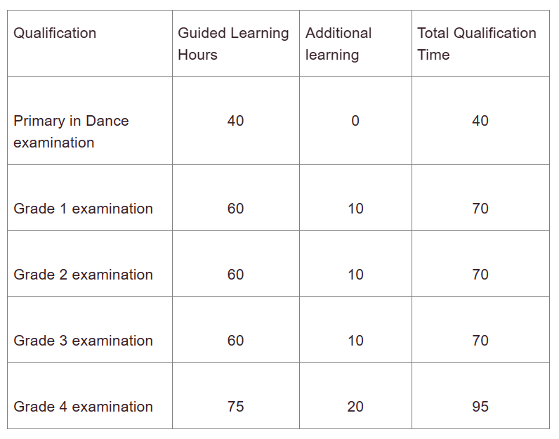

Q. Do you enter students for competitions?

A. Yes, we have both a Mini Performance Team (Grades 1-4) and a Performance Company (Grade 4+) which are invitation-only classes but students may express an interest in joining one of these classes, during which they will prepare for competitions and performances at local events.

Q. How regularly do you put on shows and do students have to take part?

A. We are well-known in the area for our shows that we produce every two years, and in recent years have been performed at the New Bury Theatre, Hurstpierpoint College. These are a highlight for our students and parents, creating lasting memories and bringing out the best in our students. However, it is not compulsory for students to take part in shows, and during show term we try to keep a number of regular syllabus classes running. Rehearsal classes are a valuable experience for all students, even they are not going to participate in shows, as students are applying their syllabus knowledge to a choreographed dance and experience the use of different choreographic devices.

Q. Do you have classes in the holidays?

A. Although our regular classes do not run during the school holidays, during most school holidays we run workshops and summer camps for pupils aged 4 upwards. Details of these are published a few months in advance along with ‘early bird’ and bundle discounts.

Q. Why are your pre-school classes only 30 minutes long?

A. Our focus as a school is the well-being of our pupils, and therefore class lengths are tailored to specific age groups and based on how long pedagogy shows that children this age can sustain concentration on one activity.

Once your child starts school, they are encouraged to take classes in multiple dance genres (Ballet, Tap and Modern) so if your child would like to take up additional classes at this age, please do not hesitate to ask us for details of all the suitable classes we have on offer for your child.

Q. How can I support my child in between classes?

A. There are various exercises that students can do between classes to help develop their strength and flexibility. However, as parents you should be wary of letting your child copy videos from sources like YouTube, particularly if they are young/inexperienced, as there is a risk they could injure themselves. On our website we have both videos and instructions for recommended stretches and exercises applicable to students of different ages which you can find here:
https://www.turningpointedanceschool.co.uk/videos

For Tap, it can be really useful for student to have a Tap board at home, which does not need to be anything fancy, a piece of plywood about 5mm thick and about 2msq is ideal.

Q. Do you offer pay-as-you-go classes for adults?

A. Unfortunately we are not able to offer pay-as-you-go options for any of our classes, including adult classes. Our teachers and venues all have to be booked in advance, and in order to ensure class viability, we require a termly commitment. However, we do offer the opportunity for people to attend suitable alternative classes within our timetable to make up for classes that they have missed. This must be agreed in advance with our School Office Manager so that attendance levels can be managed.

Q. When do I need to give notice to withdraw myself/my child from classes?

A. Six weeks’ notice to withdraw a pupil from a class must be given in writing to either the Principal or School Office Manager, otherwise six weeks’ fees will be payable in lieu of notice. This notice period is in place in order to enable us to book our teachers and venues for the following term based on the number of expected children in each class. Late cancellation of classes causes a number of difficulties and can mean that we have to disappoint other students.

